ISBN number for HWRS 2026 is 978-0-85825-008-6 (Helvetica 10pt Bold Centre)

Full Paper Template for HWRS 2026 (Helvetica 18pt Bold Centre)
First Author^{1*}, Second Author¹, Third Author² (Times 11pt Centre)
¹Author Affiliation (Times 11pt Centre)
²Author Affiliation (Times 11pt Centre)
*Corresponding Author’s Email Address (Times 11pt Italic Centre)

ABSTRACT (Times 11 Bold Centre)
Use style “Abstract”. Please include an abstract of 300 words (Times New Roman 12pt Italics Justify). Abstract should include problem statement, element of novelty, summary method, summary results, and implications for practice.

Length
The Full Paper should be between six (6) to ten (10) pages in length, including illustrations, appendices, and biography.
Do not include page numbers or any other header/footer information.

main headings (uppercase Times 11 Bold Centre)
Use the style “Heading” for main headings. The style uses ALL CAPS, bold Times 11 pt. The style introduces white space before and after the heading, so there is no need for blank lines.
The full paper must include the following sections: Introduction, Methods, Results and Discussion, and Conclusion.

Sub Headings (Capitalise Each Word Times 11 Bold Left)
Use the style Heading 1 for the second level of headings (Group Headings). The style uses ‘capitalise each word’ case, bold Times 11 pt. The style introduces white space before and after the heading, so there is no need for blank lines.

Sub-sub Headings (Times italics 11pt Bold)
Use the style “Heading 2” for the third level of headings. The style uses ‘capitalise each word’, italics, case, bold Times 11 pt. The style introduces white space before and after the heading, so there is no need for blank lines.

Page Layout
The margins should be set to 25 mm all around (top, bottom, left, and right) on A4 paper. Text should be ragged-right. Use two spaces between sentences to improve readability.

Title
Centre the title in mixed case on the first page. Do not use UPPER CASE.

Author
Below the title, centre the author's name, business or school (university) affiliation, and complete mailing address using upper and lower case letters. Authors with different affiliations should be indicared with different numbers. Provide email address only for the corresponding Author.

Body text
Use the style “Body” for all normal text. This uses 11 pt Times font with Block justification.
The main body of the paper should be in one column format.
If necessary, a Courier font may be used to distinguish URLs, eg., http//www.incose.org.

STYLES
Use the style “Figure” for figure and table captions. All tables and figuers should have captions.
Table 1 contains a list of all the styles which should be used and the purpose of each style.
Table 1. Summary of style usage. (Style “Figure” Times New Roman 11 Bold Centre)
Style | Purpose
Title | Title
Author Name | Author names and affiliations
Heading | Major Headings
Heading 1 | Subheadings
Heading 2 | Sub Sub Heading
Body | Normal Text
Figure | Captions for figures
Body with Courier | Specially delineated text such as URLs
Reference | References

Tables and Figures
Immediately prior to the first reference to a table with the actual table and number each respective table sequentially. Immediately follow the first reference to a figure with the actual figure and number each respective figure sequentially.
Numbers listed in tables should be right justified.
Figure 1 is an example of graphic inclusion. Graphics are to be embedded by the author. Images are to be pasted WITHOUT FLOATING OVER TEXT.
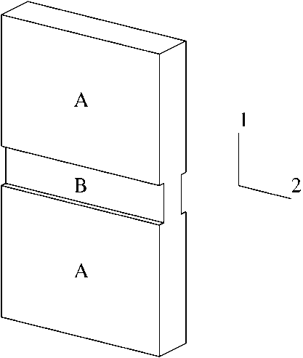
Figure 1. Example figure.

REFERENCES

Citing
Cite references within the manuscript body using parentheses that enclose last name of the author and year of the publication, for example "(Smith 1983b) described" or "was documented in (Jones et al. 1985)." A trailing lower case letter distinguishes multiple papers by the same author.
Hyperlinks can be spelt out in full (e.g. https://www.website.com.au) or shortened to be easier to read and less disruptive to the manuscrupt (e.g. according to Jones Website).

Reference List
Each entry in the list should use the style “Reference”. The list is organised alphabetically by the author's name. Multiple entries with the same author are arranged chronologically. Italicise the name of a book or journal. Note the following examples:
Rich, E., Artificial Intelligence, McGraw-Hill, New York, 1983.
Stillman, J.P., "On Heuristics for Finding Loop Cutsets in Multiply Connected Belief Networks", Technical Report, General Electric Research and Development Centre, September, 1989.
Schweiter, G.A. and Stromquist, W.R., "The Effect of Sensor Quality on Tracker/Correlator Performance", Technical Proceedings of the 1990 Joint Service Data Fusion Symposium (Laurel, MD, May 15-18, 1990). Naval Air Development Center, Warminster, PA, pp 197-222.

BIOGRAPHY
Include a short biographical sketch (50 to 100 words) for each author at the end of the final manuscript.
First Author is …. .
Second Author is …. .

